**Bal Raksha Bharat, Delhi Office**

**STEM LAB for Schools :**

Earlier, these four subjects were mostly taught in isolation and with traditional methods with no adequate infrastructure. Thus, there was the issue of integrating it into the curriculum, Moreover, without this integrated approach, there were also issues of lack of conceptual clarity and low performance in these subjects. This leads to lack of confidence among students for opting for technical courses and low performance challenges in higher grades and engineering.

Building a solid STEM foundation plugs the gaps in a lopsided theory based curriculum and also the best way to ensure that students are exposed to Math, Science, and technology in their early years. An experiential learning approach will create interest among students around STEM especially relevant to elementary level (Classes 6-10). The STEM lab will consist of a desktop, subject specific equipment and models that will promote experimentation and hands on activities in elementary level. STEM labs will be provisioned for Classes 6-10. At least two sessions per class per week will be targeted for the children to benefit from undertaking STEM lab activities. STEM education has emerged as a common term with reference to shortage of skilled workers and inadequate education in these fields. STEM education uses new technologies to enhance STEM skills. This also encourages an interest in STEM fields.

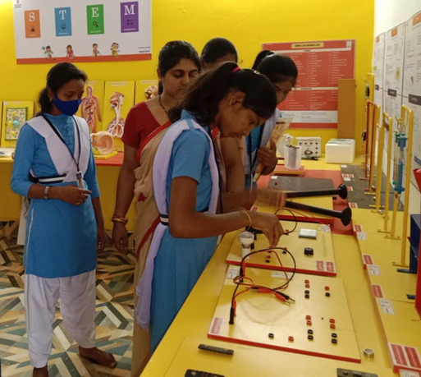STEM ( Science and Technology Engineering and Mathematics ) an innovative approach , has been adopted in many schools to make learning fun for the children. Building a solid STEM foundation plugs the gaps in a lopsided theory - based curriculum and also the innovative way to ensure that students are exposed to Science, Math, Technology and Engineering in their early years. STEM capitalizes on the curiosity of students. An experiential learning approach will create interest among students around STEM especially relevant to grades 6th to 10th classes. STEM based activity is aiming to provide an experiential learning experience to the children by improving school infrastructure and to strengthen the learning environment in project schools. The STEM laboratory may help in handling multi grade, multi-level and multi lingual teaching in Government schools especially in in our geography is having lot of families with multi lingual backgrounds from different states.

|  |  |  |
| --- | --- | --- |
| **Detail of Tools for STEM (Science and Technology Engineering and Mathematics ) Laboratory for Grades 6-10 with 80 Models** | | |
| **Sl.No** | **Model** | **Type** |
|  | **TOOLS** |  |
| 1 | Inertia of Motion | Force & Motion |
| 2 | Inertia of Rest | Force & Motion |
| 3 | Step Pendulum | Force & Motion |
| 4 | Gyroscope | Force & Motion |
| 5 | Double Cone | Work & Energy |
| 6 | Manometer | Work & Energy |
| 7 | Single Pulley | Work & Energy |
| 8 | Double Pulley | Work & Energy |
| 9 | Coupled Pendulum | Work & Energy |
| 10 | KE to PE | Work & Energy |
| 11 | Types of Magnets | Magnetism |
| 12 | Hanging Magnets | Magnetism |
| 13 | Floating Magnets | Magnetism |
| 14 | Magnetic Lines of Force | Magnetism |
| 15 | Tuning Fork | Sound |
| 16 | Doppler | Sound |
| 17 | Reflection of Sound | Sound |
| 18 | Electrical Components | Electricity |
| 19 | Electric Board | Electricity |
| 20 | Magnetic Induction (Horseshoe) | Electromagnetism |
| 21 | AC & DC Dynamo | Electromagnetism |
| 22 | Atomic Model | Chemistry |
| 23 | Structure of Atom | Chemistry |
| 24 | Automatic | Chemistry |
| 25 | Electrolysis | Chemistry |
| 26 | Phun | Chemistry |
| 27 | Wind Energy | Sustainable Energy |
| 28 | Solar Energy | Sustainable Energy |
| 29 | Heat Switch | Heat |
| 30 | Optical components | Light |
| 31 | Optic Kit | Light |
| 32 | Sliding Kaleidoscope | Light |
| 33 | Periscope | Light |
| 34 | Newton Disc | Light |
| 35 | Day & Night | Solar System |
| 36 | Constellation | Solar System |
| 37 | Pollinature | Biology |
| 38 | Plant Cell | Biology |
| 39 | Animal Cell | Biology |
| 40 | Human Skeleton | Biology |
| 41 | Human Brain | Biology |
| 42 | Human Heart | Biology |
| 43 | Human Eye | Biology |
| 44 | Human Ear | Biology |
| 45 | Human Circulatory System | Biology |
| 46 | Human Digestive System | Biology |
| 47 | Human Respiratory System | Biology |
| 48 | Human Liver | Biology |
| 49 | Human Kidney | Biology |
| 50 | Human Teeth | Biology |
| 51 | Shoulder Joint | Biology |
| 52 | Knee Joint | Biology |
| 53 | Spring Balance | Measurement |
| 54 | Roman Numbers | Measurement |
| 55 | Understanding Fraction (Disc) | Measurement |
| 56 | Understanding Fraction (Tiles) | Measurement |
| 57 | (A+B)2 - (A-B)2 = 4AB | Algebra |
| 58 | (A+B)2 | Algebra |
| 59 | (A+B+C)2 | Algebra |
| 60 | (A-B)2 | Algebra |
| 61 | A2 - B2 | Algebra |
| 62 | (A+B)3 | Algebra |
| 63 | A3 - B3 | Algebra |
| 64 | Geoboard | Geometry |
| 65 | Relationship Solids | Geometry |
| 66 | Properties Lines & Angles | Geometry |
| 67 | Triangle (Obtuse, Acute & Right Angle) | Geometry |
| 68 | Parallelogram & Its Properties | Geometry |
| 69 | Rectangle | Geometry |
| 70 | Rhombus & Trapezium | Geometry |
| 71 | Area of Circle | Geometry |
| 72 | Angle Sum Property of Triangle | Geometry |
| 73 | Angle Sum Property of Quadrilateral | Geometry |
| 74 | Angle Inscribed in Circle | Geometry |
| 75 | Interior & Exterior Angle on Triangle | Geometry |
| 76 | Sum of Interior Angles of Hexagon | Geometry |
| 77 | Area of an Arc | Geometry |
| 78 | Sector & Cone Relation | Geometry |
| 79 | Insulator & Conductor | Innovation Corner |
| 80 | Charge Sensor | Innovation Corner |
|  |  |  |
|  |  |  |
| **Sr No** | **STEM Laboratory set-up components / specifications / provisions** | |
| 1 | 80 STEM Models (Mentioned above) manuals & videos | |
| 2 | Desk Setup (24 ft x 2ft) | |
| 3 | STEM Lab Posters, Concept Poster (8) – 2ft x 2ft, Model List Poster (1) – 2ft x 2ft, Branding poster (1) – 4ft x 2ft | |

**Tentative Budget to set up one STEM Lab in school is INR 1,75,000/-**